FOR IMMEDIATE RELEASE

Local Author Publishes The Invitation, the first of three books in The Awakening Series
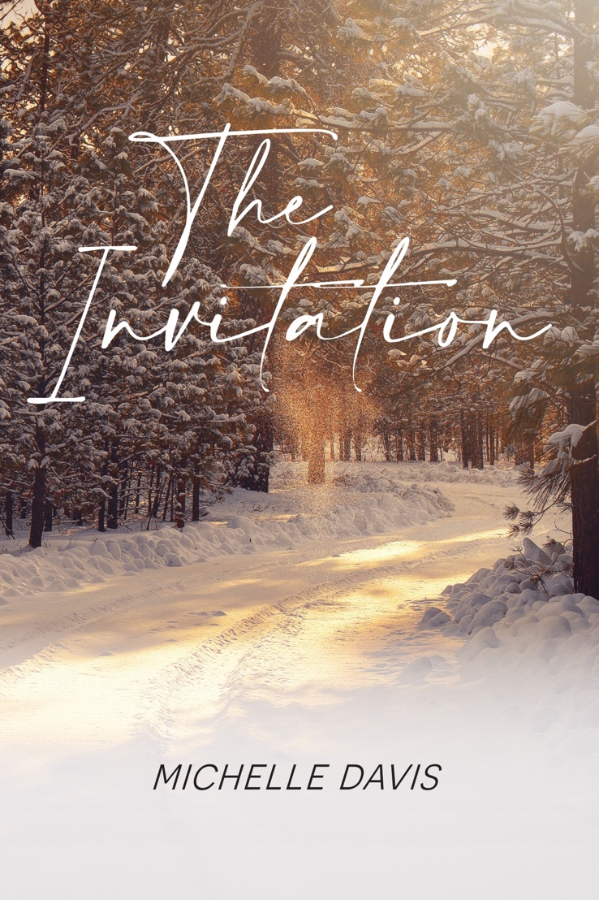

Contact: Michelle Davis
Phone: 610-207-3521
Email – michellemdavis1@me.com
Website: www.michellemdavis.net

“Opening ourselves to the possibility of alterative healing practices reminds me of watching the original Wizard of Oz movie transition from black and white to full color. In a flash, the world transforms, becoming vibrant and full of wonder.” – Michelle Davis
The Invitation, Michelle Davis’s second book, was released on December 1st and will be available for purchase at Roundabout Books as well as Amazon and other major online book retailers. A women’s fiction novel that includes a bit of mystery and romance, The Invitation shares the story of Marlee Ryan, a forty-six-year-old female from Philadelphia who ventures into the world of holistic healing and spirituality to complete an assignment for the Philadelphia Inquirer. Marlee dives deep into various practices, hoping to acquire the necessary knowledge to write this article. However, to her surprise, not only does she learn a great deal regarding these individual healing methods, but she also discovers her intuition, helping to heal past wounds and solve a murder mystery.

Novel’s Summary
Betrayal … Desire … Violence … Fear …
Though somewhat guilt-ridden from repeatedly lying to her husband, Nicki Keating’s anticipation of a passionate Valentine’s celebration with her lover overpowers all shame. But after arriving at his stunning mountain home, she encounters her darkest nightmare. Devastated and frightened, Nicki runs … but to where?
Uncertainty … Doubt … Distrust … Worry …
Marlee Ryan, a part-time journalist for the Philadelphia Inquirer, is married to an orthopedic surgeon and mother to sixteen-year-old Patrick, who is growing up more quickly than she’d like to admit. While writing comes easily to Marlee, she struggles with her most recent assignment addressing holistic healing opportunities in the Philadelphia area. After participating in several New Age practices, Marlee realizes that not only do these spiritual wellness methods help her feel renewed, but they also assist in unearthing suppressed aspects of herself. However, these lessons quickly surpass personal development when Marlee and three friends travel to the Poconos for a getaway weekend. Unexpectedly intertwined in a murder mystery, the four women utilize newly discovered gifts to uncover missing pieces to the crime. This journey of self-realization guides Marlee to release the past, listen to her intuition, and embrace the uncertainty of her future.

A quote from The Invitation:
“All week I’ve been obsessing about Tom’s office party. Mingling with some of the male surgeons’ spouses can be difficult for me. If tonight’s anything like past events, it’s bound to be filled with awkward conversations and insincere interactions.
At times, I wonder if I have anything in common with these women. At least that’s what my nagging inner voice, who I’ve come to call Margaret, has been telling me all week. Margaret’s been living in my head for some time. She means well. And I know her comments are meant to keep me disciplined, safe, someone who doesn’t make mistakes. However, Margaret’s constant barrage exhausts me. She expects perfection, and when she doesn’t get it, well, she knows exactly what to say to shatter any remaining confidence I may have.”

The Invitation is self-published by Michelle Davis, with exceptional guidance from Lieve Maas.
“Knowing I have many more stories to share, I’ve chosen to self-publish all three books in The Awakening Series, hoping to deliver these novels to readers in a timely and efficient manner.” – Michelle Davis
The Invitation will be available for purchase through Roundabout Books (Bend, Oregon), Amazon, and Barnes and Noble.
Paperback - $16.99
E-book - $6.99

Please note that 10% of the author’s net proceeds will go to ECPAT, a non-profit organization whose mission is to protect every child’s human right to grow up free from the threat of sexual exploitation and trafficking. For more information, please visit ECPAT’s website - https://www.ecpatusa.org

About the Author
“How do we learn to trust the voice within?”
This is a question author, Michelle Davis, asks daily. Michelle, whose career path includes banking, teaching, and college admissions consulting, began writing in her early fifties. Her debut novel, Learning to Bend, shares the story of Jenna Moore’s journey from a safe and predictable life in Boston to Bend, Oregon, where she begins to discover her true self. In Michelle’s next book—The Dog Walkers, available February of 2022—readers witness Ali Doyle’s reawakening from depression following a gut-wrenching break-up. Michelle’s latest venture, The Invitation, delves into the world of spirituality and holistic healing. This book is the first of three in The Awakening Series (stay tuned for The Retreat and The Healers). In addition to writing women’s fiction, Michelle’s blog, “elevate,” explores finding inspiration, increasing vibration, and embracing limitless possibilities. To learn more about Michelle or read her blogs, visit www.michellemdavis.net

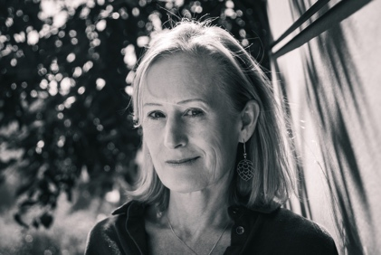
Questions for Michelle:
How do you develop your plot and characters?
The plot usually just comes to me. I know that sounds cliché, but it’s the truth. I’ll often wake up with an idea, or sometimes, while running or even in the shower, I’ll get a thought about the next turn in the book. Regarding characters, that is the fun part. I like to allow my imagination to play and create. Sometimes I’ll look on-line to find pictures of how I think my characters might look like, but it’s usually just to have a tangible representation of what is already in my head. I also like to spend time creating characters’ backstories. Often, during long drives, I’ll run ideas past my husband to see if these individuals are believable. He’s pretty awesome at giving me honest feedback.

What, in your opinion, are the most important elements of good writing?
The first thing that pops into my mind is authenticity. For me, if the writing isn’t authentic to the writer—meaning that it sounds contrived or designed to sell books/please audiences—then something about it makes me wonder if this is the author’s best work.
Another important element of writing is creating believable characters. Can I relate to them, are they multi-dimensional?
Finally, I like to be able to visualize the scene and put myself right there, next to the characters. Does the author provide clear descriptions? Is there movement during the scenes? Does he or she employ language which taps into my senses?

Do you ever suffer from writer’s block? If so, what do you do about it?
Yes, I have hit a wall when writing. Sometimes all that I need is to get away, so I go for a run, take a walk with the dogs, or just go about my day, hoping that at some point inspiration will hit. This usually does the trick. However, separating myself from my work is not always the answer to writer’s block. Four years ago, I had written most of the first draft of this book, but I just couldn’t finish it. I was not able to make the ending come together in a believable fashion. For me, this was writer’s block at it’s worse. So, I shelved the manuscript for three years, realizing I had more to learn before I could finish the book. I continued to pick it up and put it down several times until the missing pieces finally became clear.

What is your favorite quote and why?
“When you know better, you do better.” - Maya Angelou
This quote perfectly depicts what it’s like to be human. We’re constantly learning, evolving, and becoming better. But it requires experiences and lessons from those encounters. Sometimes we regret past actions and cast blame on ourselves. However, if we were trying our best with the tools that we had, then that was all we could do. But now that we know better and are aware of different ways, it is our responsibility to do better. The same applies to others and how they’ve impacted our lives. To me, this quote epitomizes how we can all elevate to our higher selves.

First book you remember making an indelible impression on you.
Tuck Everlasting, by Natalie Babbett, rocked my world at age twenty-four. At the time I was teaching fourth grade at Waldron Mercy Academy in Merion Station, a suburb of Philadelphia. I chose it as a read aloud book for my students—what I’d read at the end of the day before dismissal. Tuck Everlasting helped me understand why we age and how this is the necessary natural process for all of us. Winnie’s struggle of whether to drink the stream water, guaranteeing her everlasting life, prompted a great deal of thought for both my student and for me. It’s still one of my all-time favorite books.

If you could have one paranormal ability, what would it be?

I would like to be Claircognizant. I would love to be able “know.” This ability would provide insight to make the best possible decisions. But more importantly, “knowing” might allow me to deliver intuitive writings—whether books, blogs, or informational pieces—as I would have a truer understanding as to how it all works.

If we were to come to your house for a meal, what would you give us to eat?
I LOVE this question because cooking is so much fun. Here you go:
Appetizers: Cheese and crackers along with freshly cut veggies served with hummus. My husband would make his famous margaritas.
Salad: Caesar salad.
Entrée: A bowl consisting of quinoa, black rice, or roasted chopped sweet potatoes. Then I’d add a variety of sautéed veggies – spinach, zucchini, asparagus, mushrooms, and broccoli. After that I’d then top it with a protein, most likely shrimp or chicken. Finally, I’d add shaved parmesan, sliced almonds, and micro greens.
Desert: Chocolate peanut butter brownies. And, of course, we’d serve yummy wine.

What is the sweetest thing someone has done for you?
When I had breast cancer, I had to undergo a double mastectomy and then four rounds of chemo. My husband was always by my side—Scott was beyond amazing. He would gently wash my hair in the sink when I was unable to wash my own hair in the shower. And when I’d be feeling nauseous from the chemotherapy, he’d make me bacon sandwiches on mushy white bread—the only thing I could stomach. Scott was incredible throughout that entire journey.

What books or authors have most influenced your own writing?
Amy Impellizzeri, author of Lemongrass Hope, The Truth About Thea, The Secret of Worry Dolls, and Why We Lie, encouraged me to attend her writers’ workshop. That was my introduction to writing (not counting my freshman writing class at Lehigh University). She’s been a dear friend ever since and has served as my mentor.
It’s hard to pinpoint a particular book, as I believe my writing is still in its infancy and am unsure as to where it is headed. But I’d have to say that I love the intriguing story line of The Celestine Prophecy. Additionally, the characters are beautifully developed in A Gentleman in Moscow.

What is your favorite television show?
I love watching Friends. I think I’ve seen every episode multiple times. In fact, when I’m home alone at night, I’ll watch rerun after rerun—sometimes till one in the morning. I recently had the “aha” moment that most likely my fondness for Friends connects to my childhood when I loved the Archie comic book series. The characters are almost identical. Plus, Friends has the most amazing cast. Wouldn’t you want them to be your friends with Monica, Phoebe, Rachel, Ross, Joey, and Chandler?

Do you ever wish you were someone else? Who?
When I was four, I wanted to be “Bat Girl” because I loved the television show, Batman, and I wanted to catch “the bad guys.” But I’m guessing that’s not the answer you’re looking for.
During high school I would have loved to have been the popular girl—you know, the tall, thin girl with perfect long blonde hair that everyone loves. Instead, I was the average looking girl who worked hard and got straight A’s. I was nice and had good friends, but I always felt as if something about me was missing. Perhaps what was “missing” was me being authentic to who I truly was … I was kind of nerdy (I think I still am today). No doubt I was uncomfortable in my own skin and thought I had to be someone who I wasn’t. But now that I’ve “grown into myself,” I’ve come to realize how often our perceptions of others can cause us to feel “less than.” It’s too easy to judge another’s strengths and weaknesses then draw imaginary parallels as to how we compare. This is an incredibly unhealthy practice, yet my guess is that we all do it from time to time. So now, I’m incredibly happy to be me, as I try to accept all parts of who I am—the good, the bad, and the in between. That’s one of the blessings of aging … we begin to let go, trust, and allow as we become closer to unconditionally loving ourselves and others.

What is one thing your readers would be most surprised to learn about you?
I think readers would be surprised to learn that I have my Reiki 3 certification. In fact, I receive energy healing every two weeks, helping to keep my chakras balanced. Not only do I believe it’s important to “work out” our physical body, but it is equally, if not more valuable, to “work on” our energetic bodies.

“The spiritual journey is the unlearning of fear and the acceptance of love.” — Marianne Williamson
“You can have a spiritual awakening and discover a new side of you at any age. And best of all, love can happen at any age. Life can just start to get exciting when you’re in your 40s and 50s. You have to believe that.” — Salma Hayek

“Who looks outside, dreams. Who looks inside, awakens.” — Carl Jung

